Version 0.1

Version History:

|  |  |  |  |  |
| --- | --- | --- | --- | --- |
| Sr. No | Version | Date | Author | Comments |
| 1 | 0.1 | 5th July 2021 | Sonal Hirlekar | Documented Implementation and Set up details |

Table of Contents

1. Overview 2

1.1 Architecture using Page object model: 2

1.2 Folder structure for the project: 3

2. Setup Instructions 4

2.1 Pre-requisites: 4

2.2 Download & Import the provided project into Eclipse 6

3. Execution of Test Suite 11

3.1 Via Eclipse IDE 12

3.2 Via CMD 13

4. Reporting using Extent Reports 15

# 1. Overview

* **IDE:** Eclipse
* **Programming Language**: Java
* **Project type:** Maven – for build, execution, and dependency purpose

## 1.1 Architecture using Page object model:

All TestCase classes Extends BaseClass

**Base.java**

Root class for all the child pages, Tests, Utilities

Read Properties, WebDriver Initialization, BeforeTest and AfterTest

**Env. variables, Configuration files, other -3**

**Utility Components - 2**

**Page Layer-1**

**(PageObjects)**

MainPage.java

Drivers (for IE, Chrome, Firefox)

Config.properties

POM.xml

Testng.xml

Extent reports

Listeners

DataProviders

Log

DSL_searchResults.java

DSL_Tarifdetails.java

**TestCases**

TC_01_Verify_DSL_Calc.java

TC_02_Load_Mul_Tariff_Pages.java

TC_03_Verify_Offer_Details.java (Executes for 2 Data Parameters)

testng.xml

POM.xml

## 1.2 Folder structure for the project:

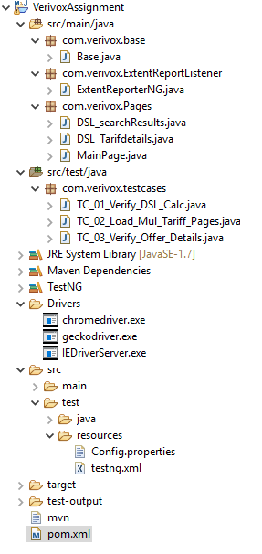

# 2. Setup Instructions

## 2.1 Pre-requisites:

***Download JDK (1.8 & above) and install it in the default C: drive***

Set environment variable for Java (until the bin folder) in the ‘System variables’ section

* Create a new variable  
  **JAVA_HOME = C:\Program Files\Java\jdk-15.0.2**

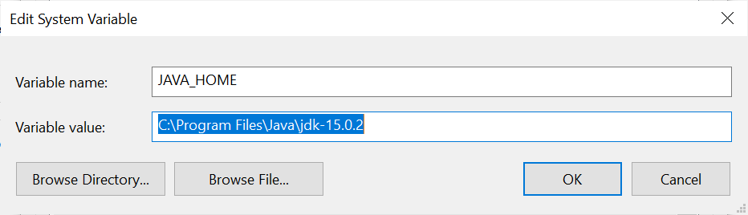

* Also edit the ‘Path’ variable and add the path:  
  **C:\Program Files\Java\jdk-15.0.2\bin**

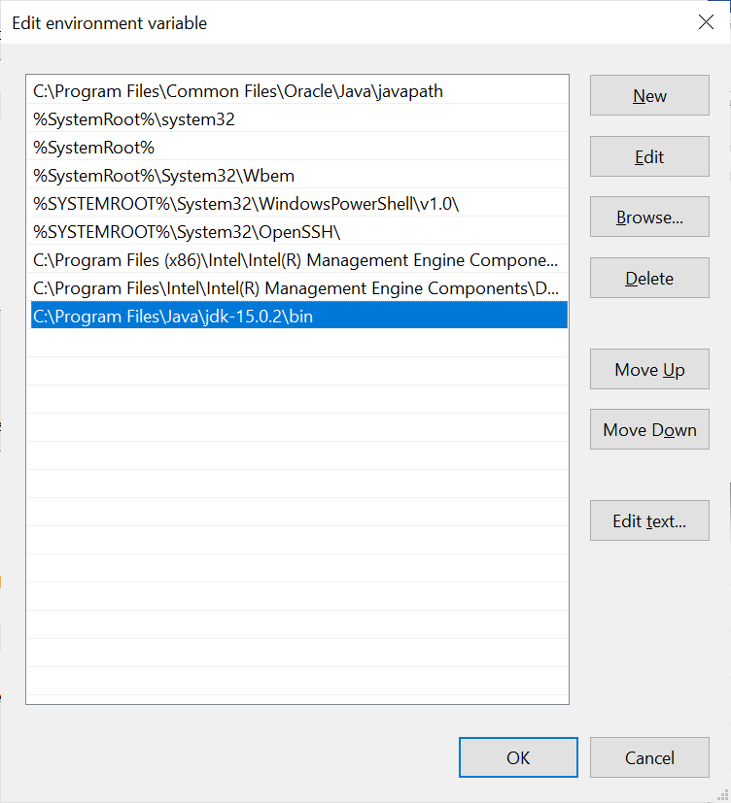

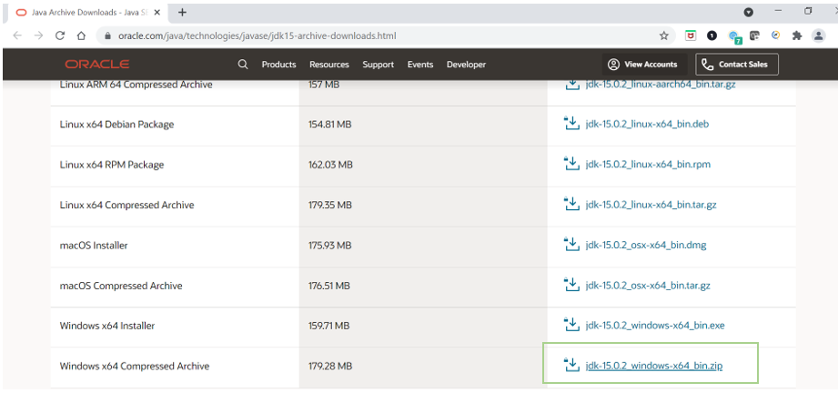

***Download and install Eclipse***

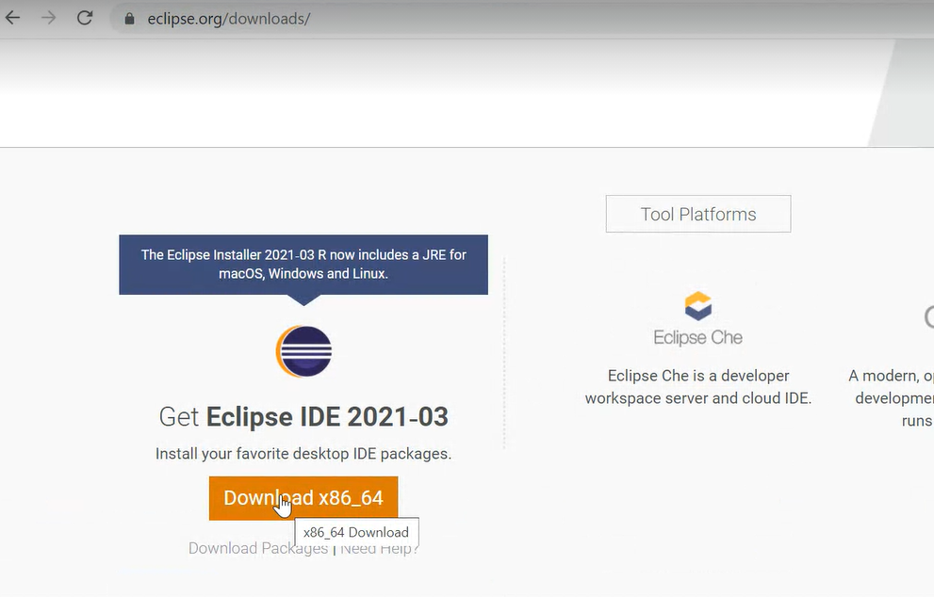

***Download Maven (latest build 3.6.3) and extract the zip file.   
Move the unzipped folder to C: drive***

Set environment variable for Maven (until the bin folder) in the ‘System variables’ section

* Create a new variable  
  **MV_HOME = C:\apache-maven-3.8.1-bin\apache-maven-3.8.1**
* Also edit the ‘Path’ variable and add the path:  
  **C:\apache-maven-3.8.1-bin\apache-maven-3.8.1\bin**

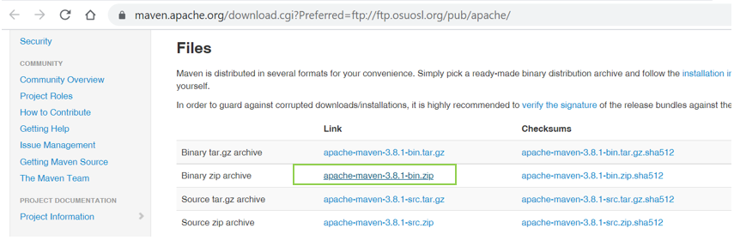

## 2.2 Download & Import the provided project into Eclipse

* Complete Assignment and ‘Implementation and set up’ guide can be downloaded from:   
  <https://github.com/sonal-project/Verivox-Assignment>

Uploaded the same on google drive as well:

<https://drive.google.com/drive/folders/1My0Sjgr7qQVTccAf_h_lNFZJX76UmN2z?usp=sharing>

* ***Extract the zipped folder*** (since we need to provide the unzipped folder for importing)
* In the Eclipse IDE Launcher choose the project for workspace

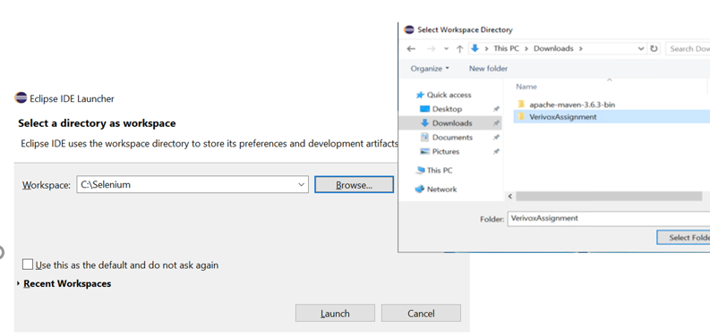

* Import steps:
  + On Eclipse IDE, go to ‘File’ tab and choose the option ‘Import’

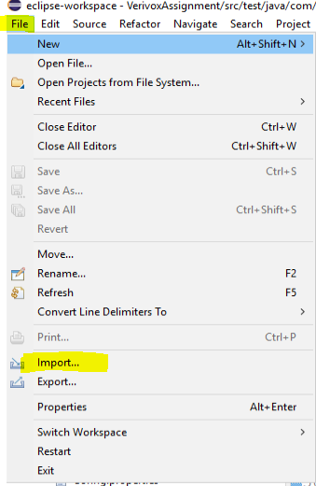

* + Choose the option ‘Existing Maven Projects’ and click on ‘Next’ button

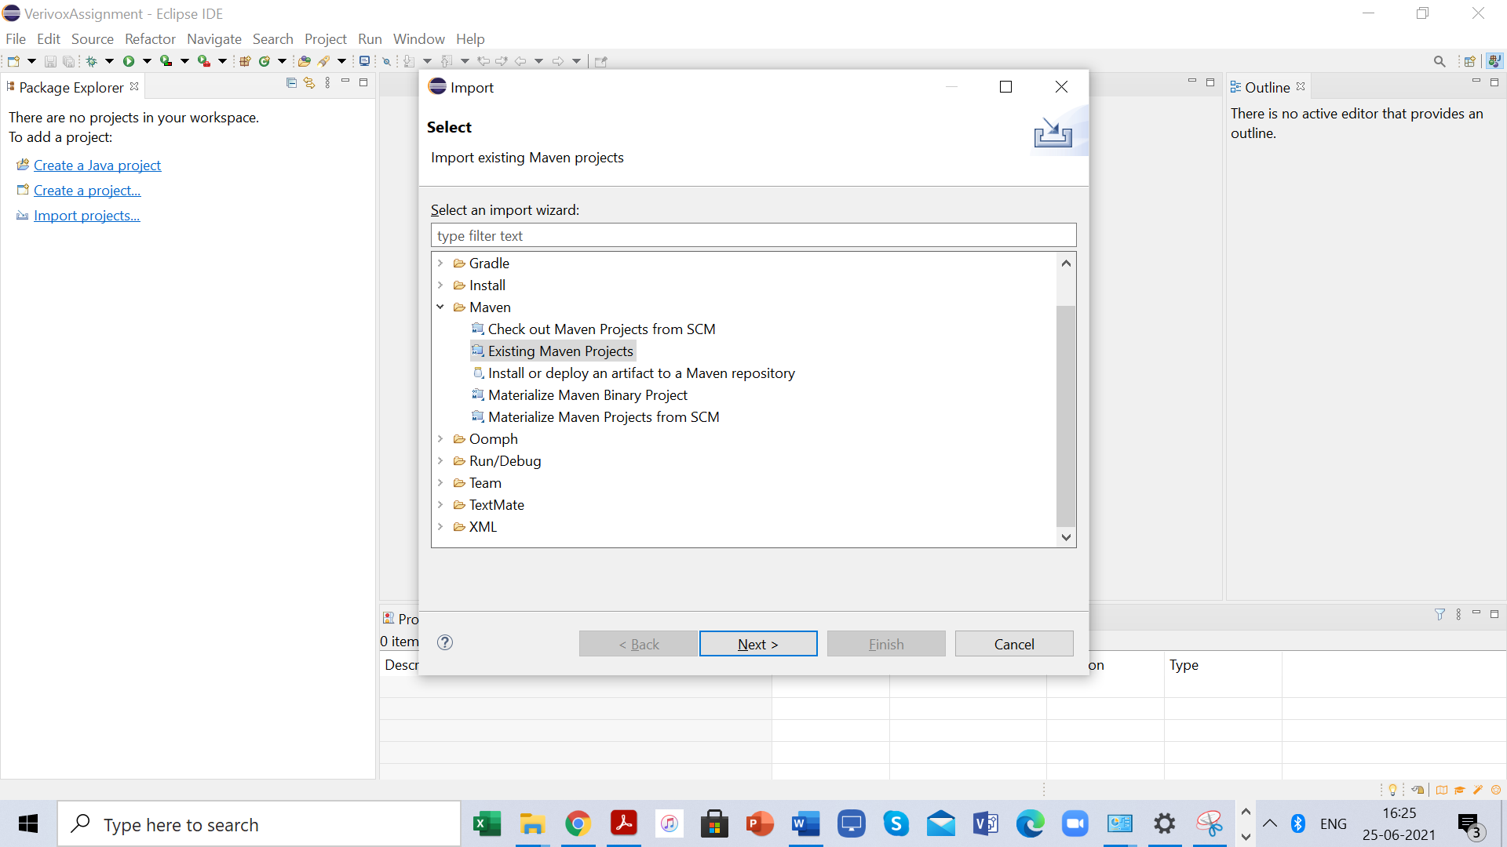

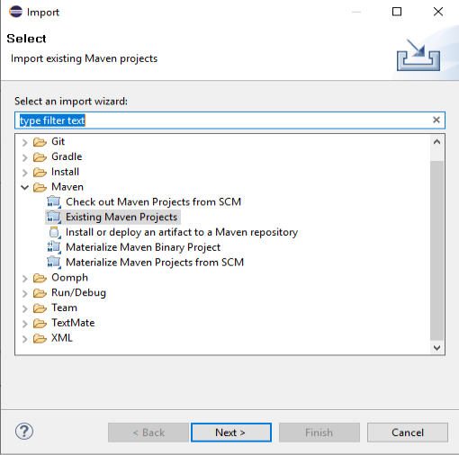

* + Browse to the directory where the project was downloaded (select the path till the folder which contains ‘pom.xml’)  
    Remember to check the checkbox for pom.xml and click on Finish

(Browser till the folder which contains pom.xml file)

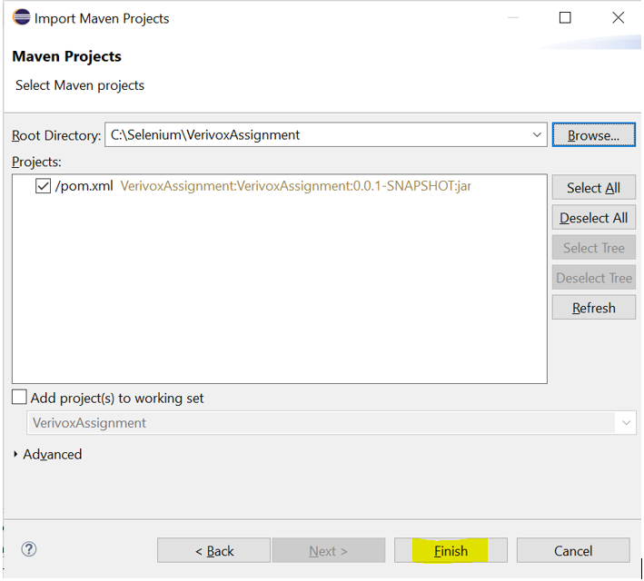

* Project should be visible now in Eclipse IDE  
    
  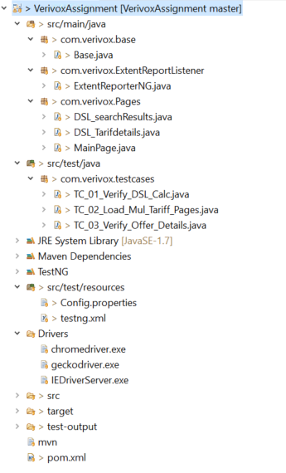

# 3. Execution of Test Suite

The Test Suite can be executed in many ways:

* Via Eclipse IDE
* Via Command Line (CMD)

Check the browser versions for your system and download respective selenium web driver’s version. Keep the respective driver’s ‘.exe’ file on “Drivers” folder

We have used Chrome browser Version 91.0.4472.124 (Official Build) (64-bit) (TestCases support all 3 browsers: IE, Chrome, Firefox)

Change the value in property file according to your browser requirement

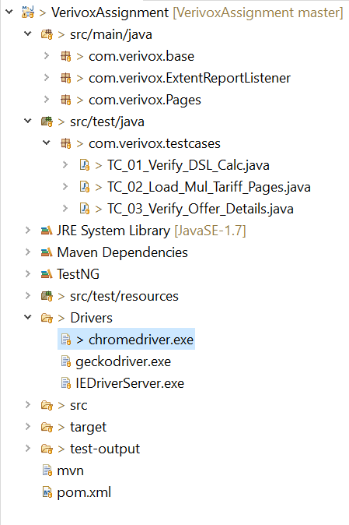

## 3.1 Via Eclipse IDE

**Pre-requisites**: ***Download and install TestNG for eclipse plugin from Eclipse Marketplace  
Help > Eclipse Marketplace> Search TestNG > install TestNG for eclipse plugin***

* + Go to: ‘src/test/resources’ folder and expand it
  + Right click on ‘testng.xml’ file > Select ‘Run as’ > Select ‘TestNG suite’
  + The test suite execution will start

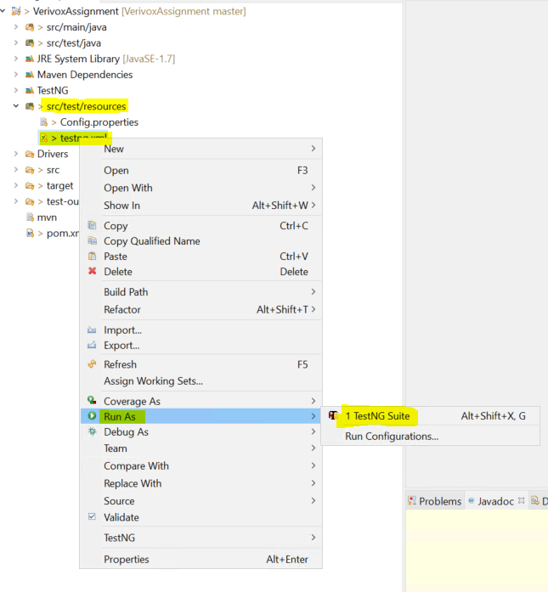

## 3.2 Via CMD

**Pre-requisites:** to be completedas mentioned above

* Eclipse should be installed, and the Maven project should be imported
* JDK & Maven should be installed, and environment variables must be set

**Steps to be followed:**

* Open Command line on your system
* Go to the directory where the project is located by using the command:
  + **cd mention-project-location**

For e.g. the path for my execution was:

C:\Selenium\VerivoxAssignment  
  
So my command to change the directory was:

**cd C:\Selenium\VerivoxAssignment**



* Once you are in the project directory, follow the below commands in the mentioned order:
* **mvn clean**
* **mvn clean test**

**OR**

**mvn clean test -DtestngFile=testing.xml**

* The test suite execution will start
* After successful execution, you should see the result as BUILD SUCCESS:

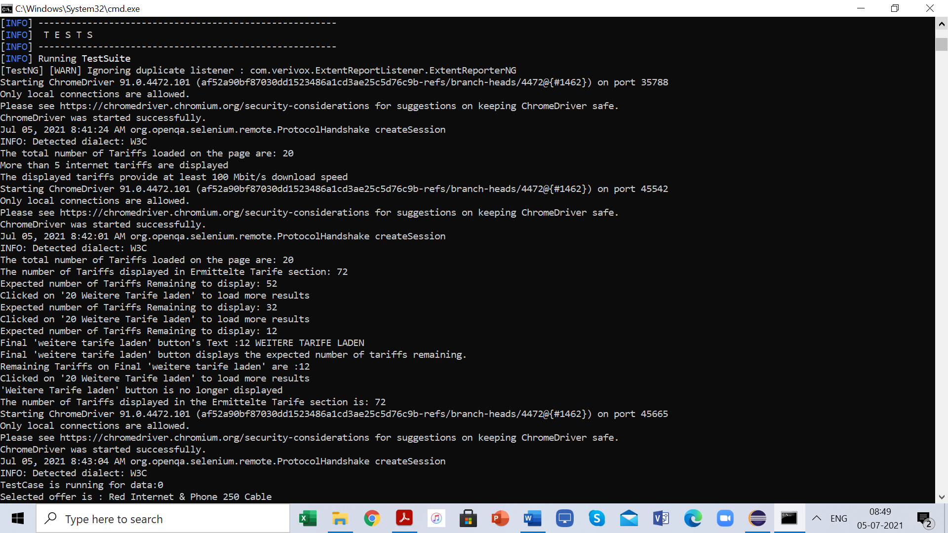

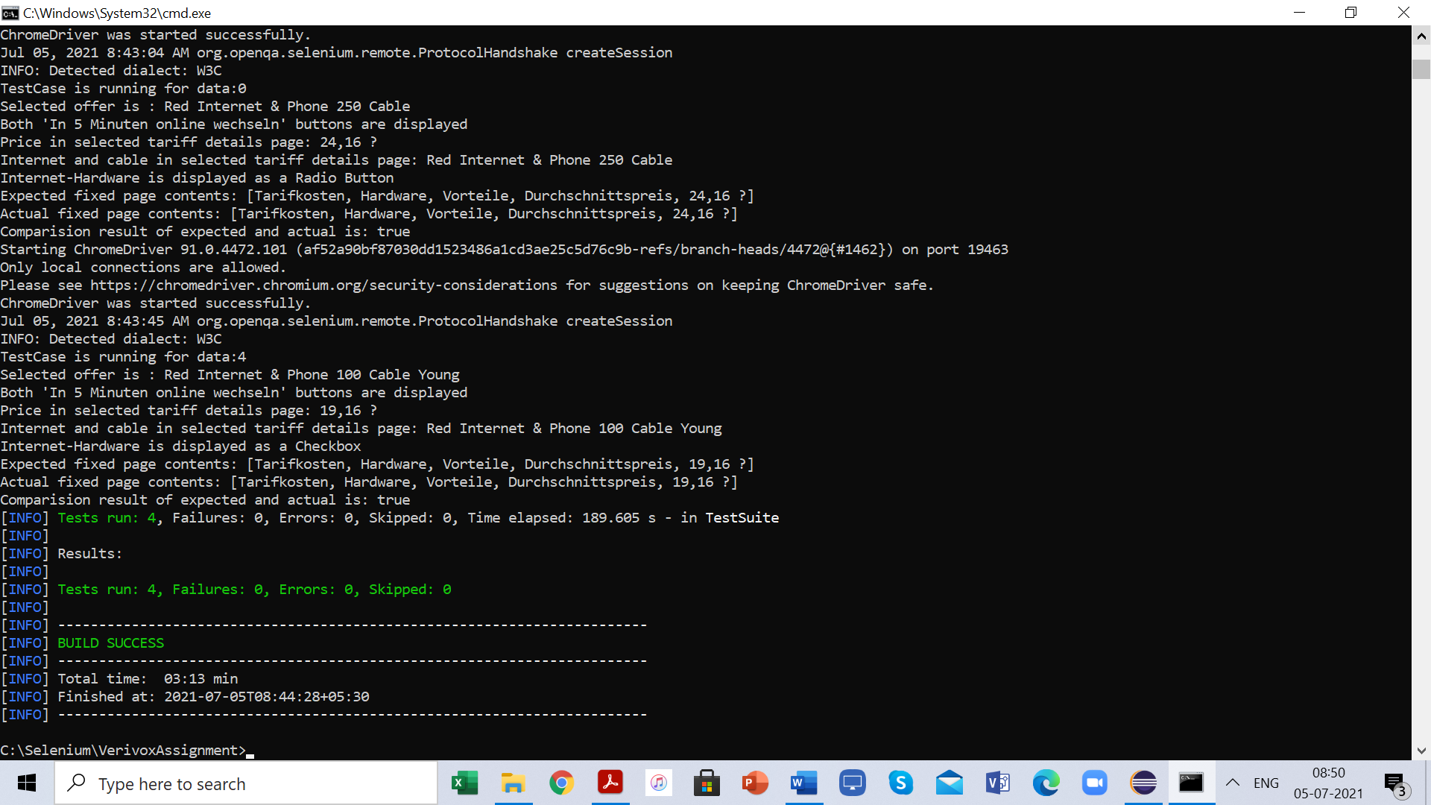

# 4. Reporting using Extent Reports

* We have created a java class file for Extent Report Listener
* We have added this as a listener in testing.xml file
* Reports can be found in the target output folder

